Online student portal- web application
User login test cases

Module Name: Online student portal system-user login test cases(Web)
Test case ID: TC002
Platform: Web application(Responsive)
Login Method: username + password+Captcha

Home page

Scenario ID: 1
Scenario: login with valid credentials
Test steps:
- Enter valid username :2504030400032
- Enter valid password:vidhip@1499
- Enter valid Captcha:3FD1A9
- Click on login

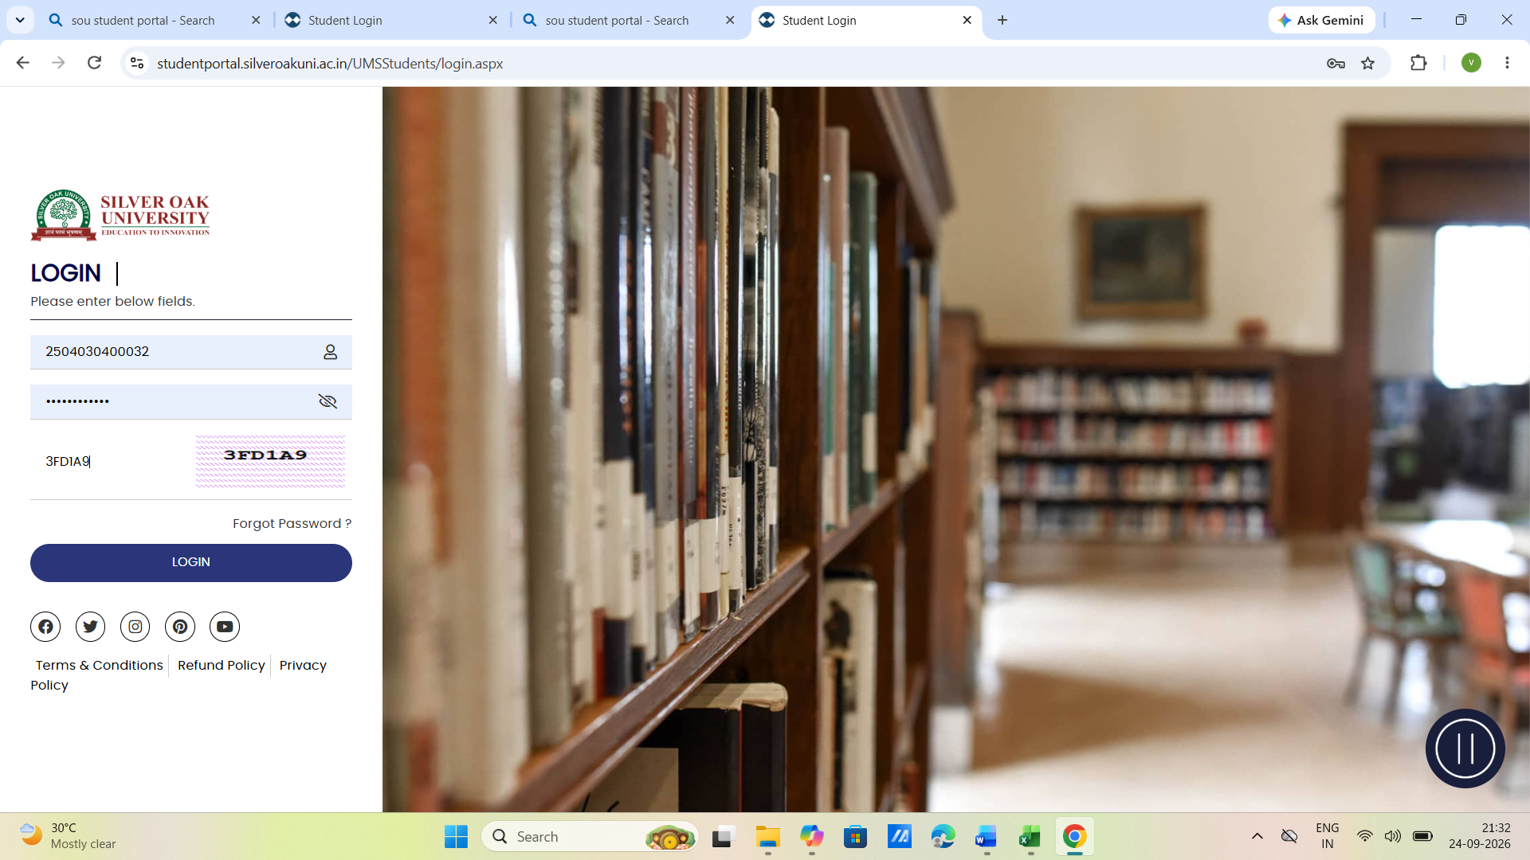

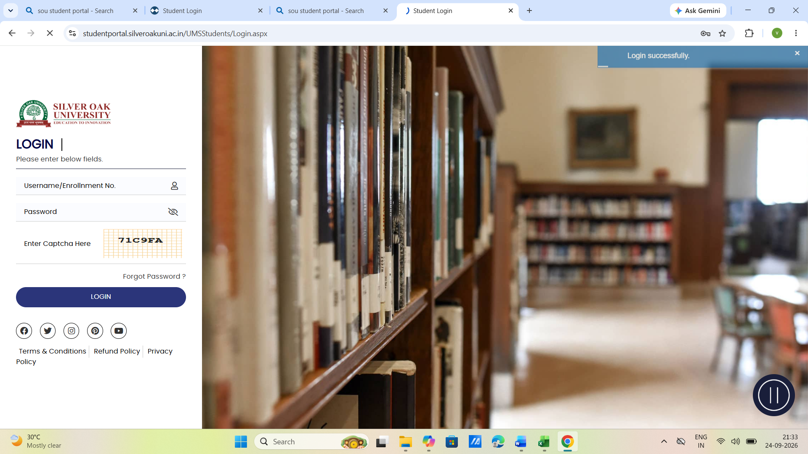
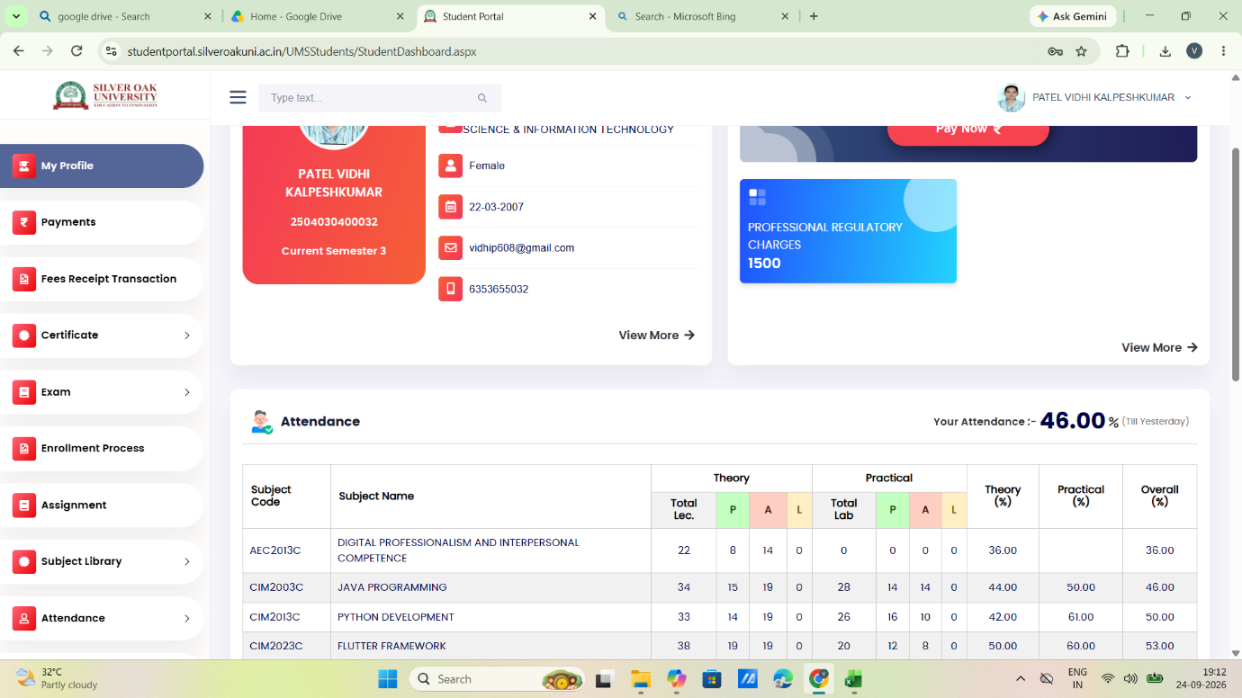

Scenario ID: 2
Scenario: login with invalid password
Test steps:
- Enter valid username: 25040300032
- Enter invalid password: wrongpass
- Enter valid captcha:843D77
- Click on login
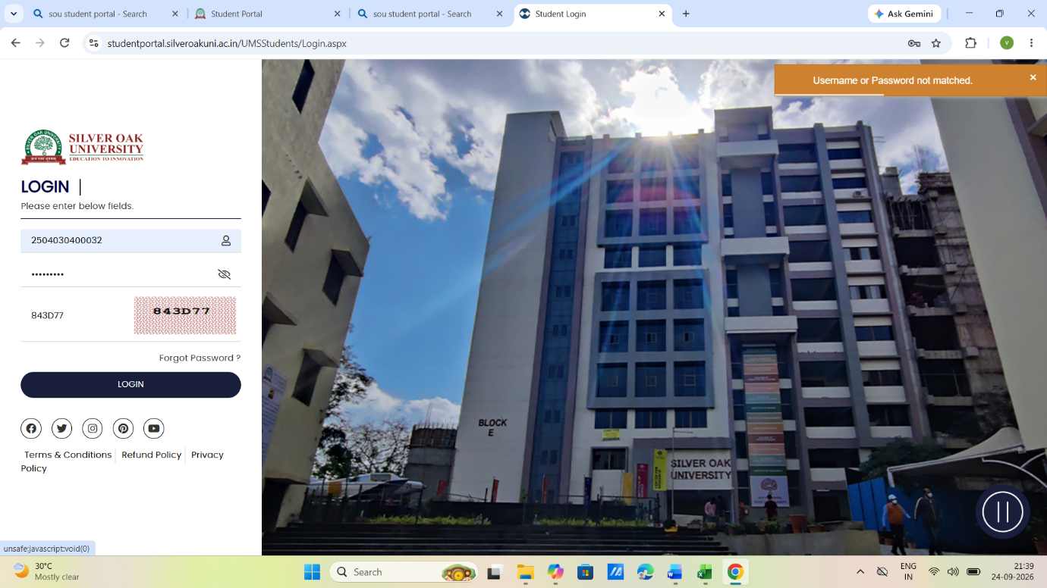

Scenario ID: 3
Scenario: login with invalid username
Test steps:
- Enter invalid username: 2555030500021
- Enter valid password: vidhip@1499
- Enter valid captcha:843D77
- Click on login
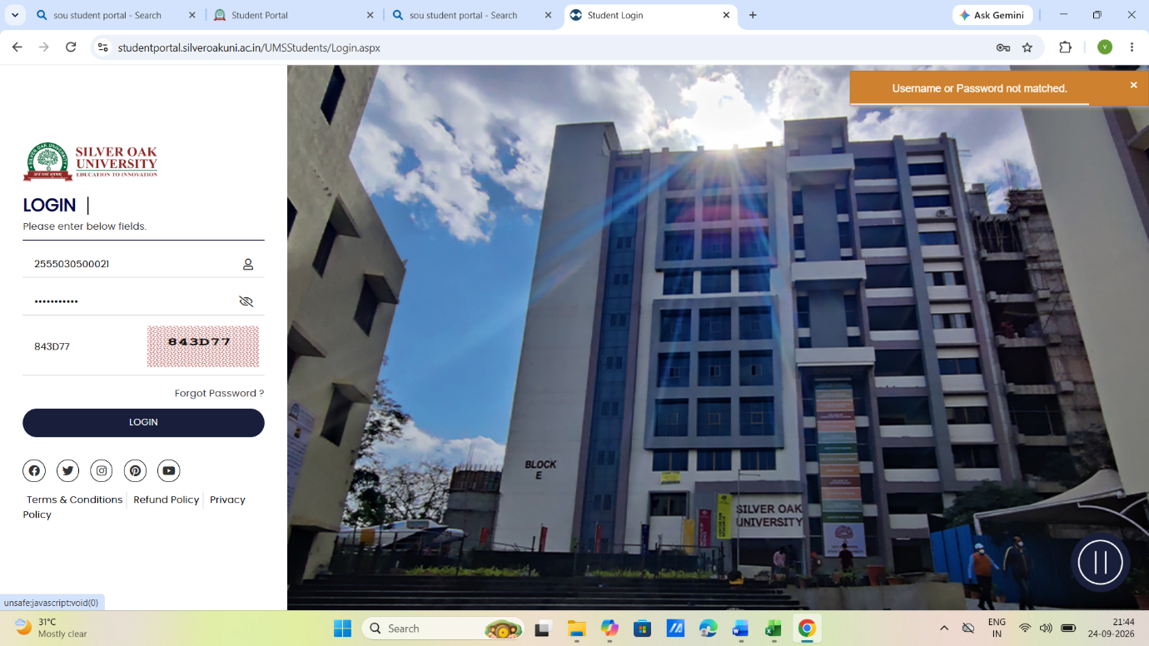
Scenario ID: 4
Scenario: login with blank fields
Test steps:
- Enter username: -
- Enter password: -
- Enter captcha:-
- Click on login

Scenario ID: 5
Scenario: login with invalid password and invalid username
Test steps:
- Enter invalid username: 2555030500021
- Enter invalid password: wrongpass
- Enter valid captcha:843D77
- Click on login

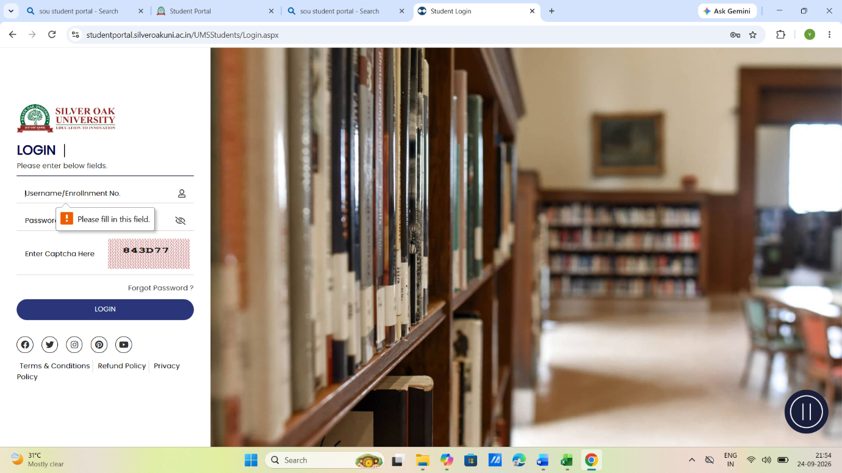
Scenario ID: 6
Scenario: login with valid password, valid username and invalid captcha
Test steps:
- Enter valid username: 25040300032
- Enter invalid password: vidhip@1499
- Enter valid captcha: 112345
- Click on login
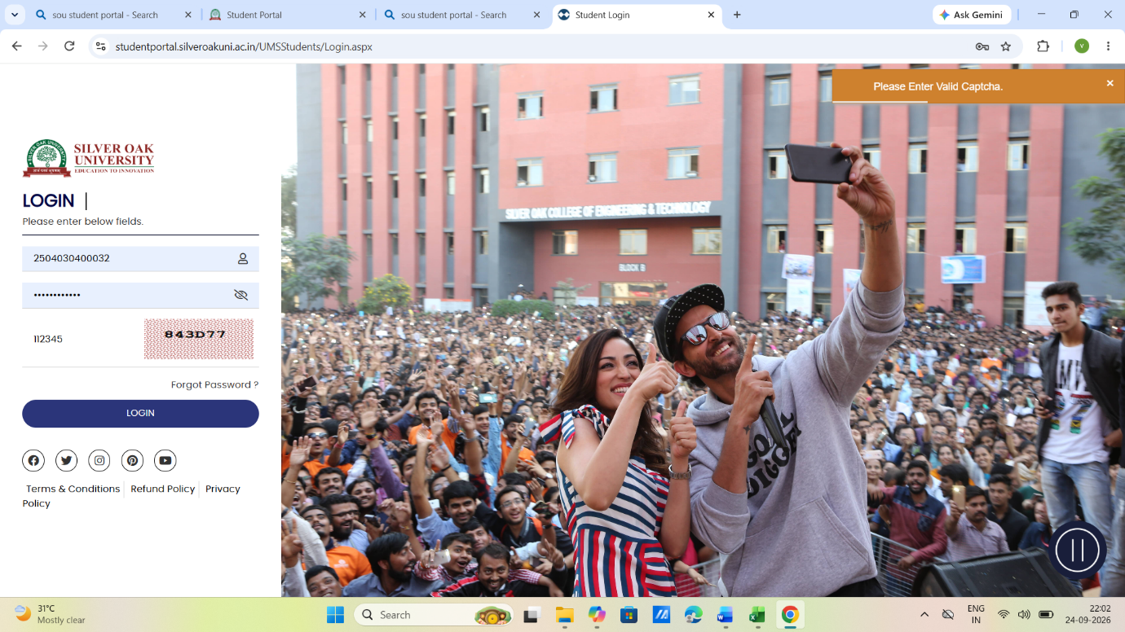
Scenario ID: 7
Scenario: Cross Browser test
Test steps:
- Enter valid username: 25040300032
- Enter invalid password: vidhip@1499
- Enter valid captcha: 71C9FA
- Click on login
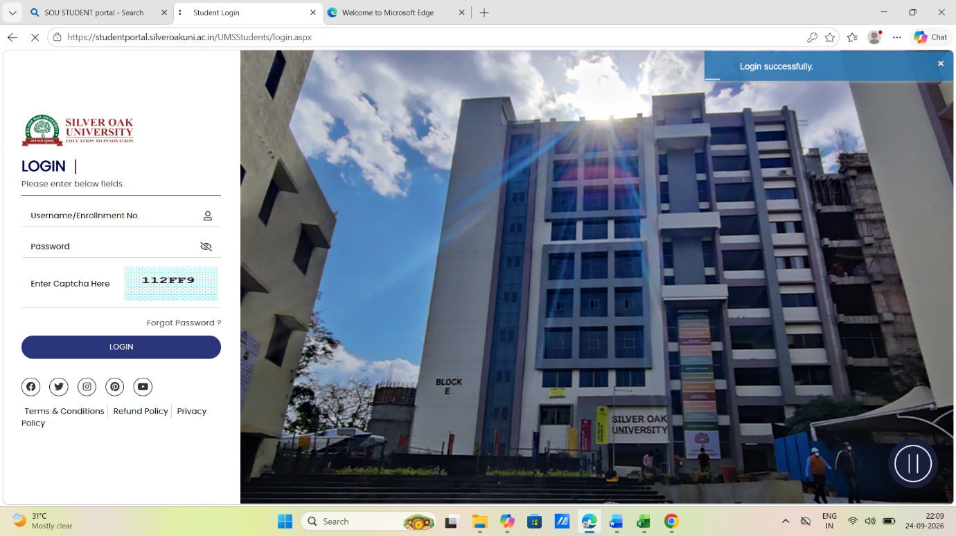

Scenario ID: 8
Scenario: logout funtionality
Test steps:
- Enter valid username: 25040300032
- Enter invalid password: vidhip@1499
- Enter valid captcha: 71C9FA
- Click on login
